SCREENSHOTS FOR MACHINE PROBLEM 3(PYTHON)

**SCRIPT:**

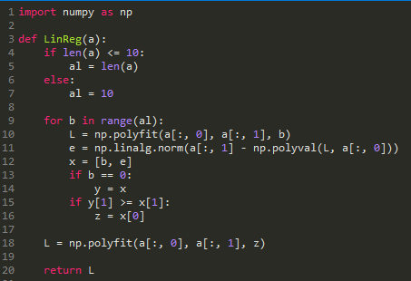

**OUTPUT:**

